Student’s Name: Darshini Venkatesha Murthy Nag

SID: 016668951

Professor’s Name: Andrew Bond

Date: 09-07-2022

**CMPE_272_Homework_1 – Ansible**

Git repo URL: <https://github.com/darshcloud/CMPE_272_HW1_Ansible.git>

**Step 1:** Created 3 Ubuntu EC2 instances on AWS. Below are the details

* Name: AnsibleServer

Public IP: ec2-13-56-160-12.us-west-1.compute.amazonaws.com

* Name: WebServer-1

Public IP: ec2-54-183-189-25.us-west-1.compute.amazonaws.com

* Name: WebServer-2

Public IP: ec2-54-67-92-71.us-west-1.compute.amazonaws.com

**Step 2:** Generated RSA key pairs for the all the three ec2 instances created and saved the private key.

Keypair created for ec2 instance named AnsibleServer

Keypair created for ec2 instance named WebServer-1

Keypair created for ec2 instance named WebServer-2

**Step 3:** Allowed HTTP and HTTPs traffic on WebServer-1 and WebServer-2 ec2 instances during instance creation and configure security group to allow traffic on port 8080.

WebServer-1snapshot:

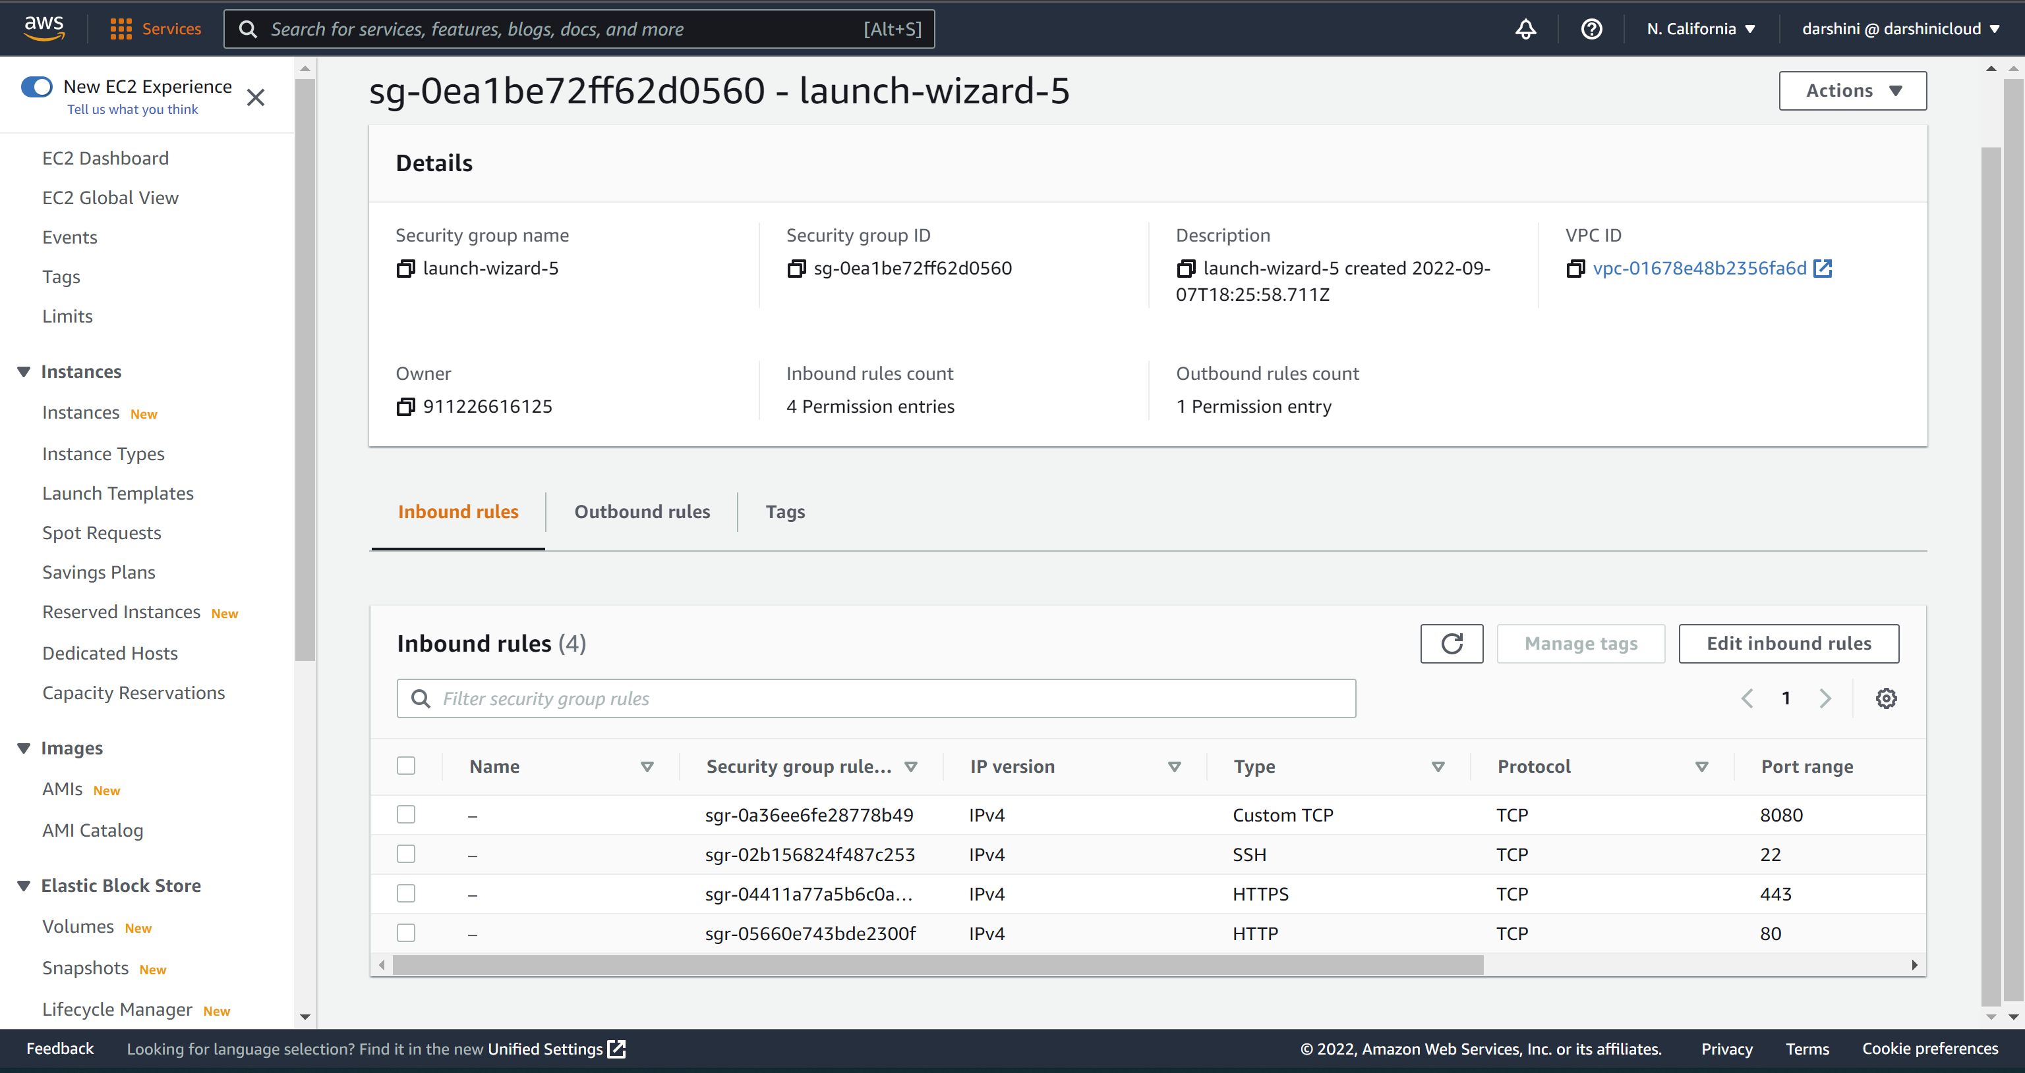

WebServer-2 snapshot:

**Step 4:** Steps followed to install Ansible on AnsibleServer EC2 instance.

1. Connected to AnsibleServer EC2 instance remotely through ssh.

1. Using the below commands to install python and ansible on AnsibleServer ec2 instance.

sudo apt-get update

sudo -i

apt-get install python3

apt-get install ansible

1. Ansible installed.

ansible --version

**Step 5:** Created hosts file and added the webservers to the file.

**Step 6:** Made the below changes to ansible.cfg file

**Step 6:** Connectivity check done by pinging the webservers with the below command

ansible -i hosts webservers -m ping

**Step 7:** Created Two ansible playbooks for deploying and undeploying webserver resources.

webserver_deploy.yml

webserver_undeploy.yml

**Step 8:** To deploy the webserver resources used the below command

Ansible-playbook webserver_deploy.yml

**Step 9:** To undeploy the webserver resources used the below command

Ansible-playbook webserver_undeploy.yml

# References

Ansible Documentation: <https://docs.ansible.com/>